**Analysis On MeddiBuddy Data**

1. **Does the gender of the person matter for the company as a constraint for extending policies?**

**Answer** – No, gender of the person doesn’t matter for the company as a constraint for extending policies.

**Justification** –

Males and Females are equally contributed in Policy. that's why gender of the person doesn’t matter for the company as a constraint for extending policies.

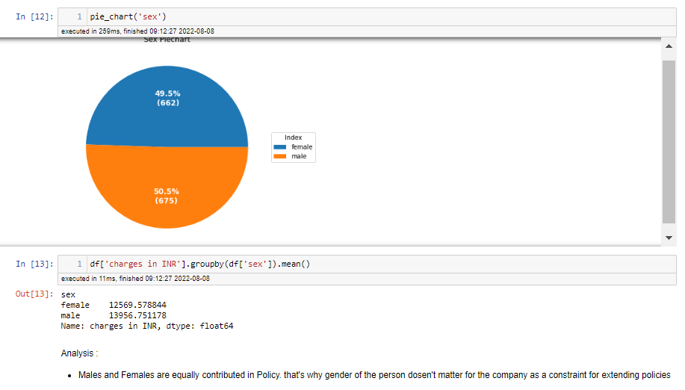

1. **What is the average amount of money the company spent over each policy cover?**

**Answer** - The average amount of money the company spent over each policy cover is: **13270.42 INR**

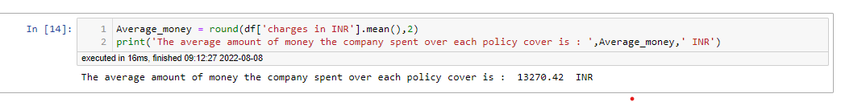

1. **Could you advice if the company needs to offer separate policies based upon the geographic location of the person?**

**Answer** – No, we will not advice the company to offer separate policies based upon the geographic location of the person.

**Justification** –

There is no significant Difference between the regions to contributing Policy And Charges. so we will not advice the company to offer separate policies based upon the geographic location of the person.

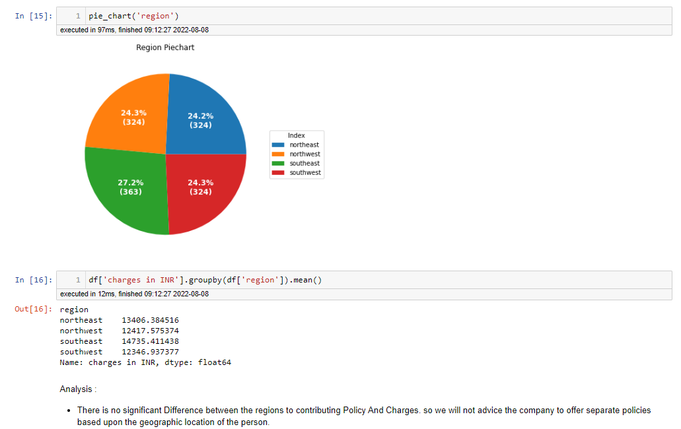

1. **Does the no. of dependents make a difference in the amount claimed?**

**Answer** – Yes, no. of dependents make a difference in the amount claimed

**Justification** –

Yes, no. of dependents makes a difference in the amount claimed. we can see Person with no dependents claimed less amount than person who has more than 1 or 2 dependents. person who has more than 4 dependents claimed less amount.

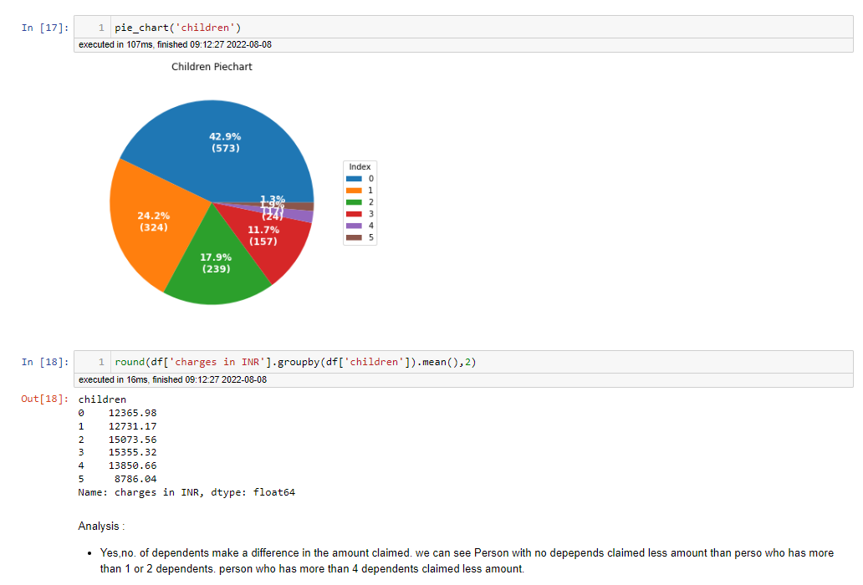

1. **Does a study of persons BMI get the company any idea for the insurance claim that it would extend?**

**Answer** – Yes, company can extend Based Insurance on Study of BMI.

**Justification** –

Person with high BMI claimed high amount than Person who has low BMI. The person who are in young age have low BMI and Paying Less. So, company can extend insurance for young persons who has low BMI.

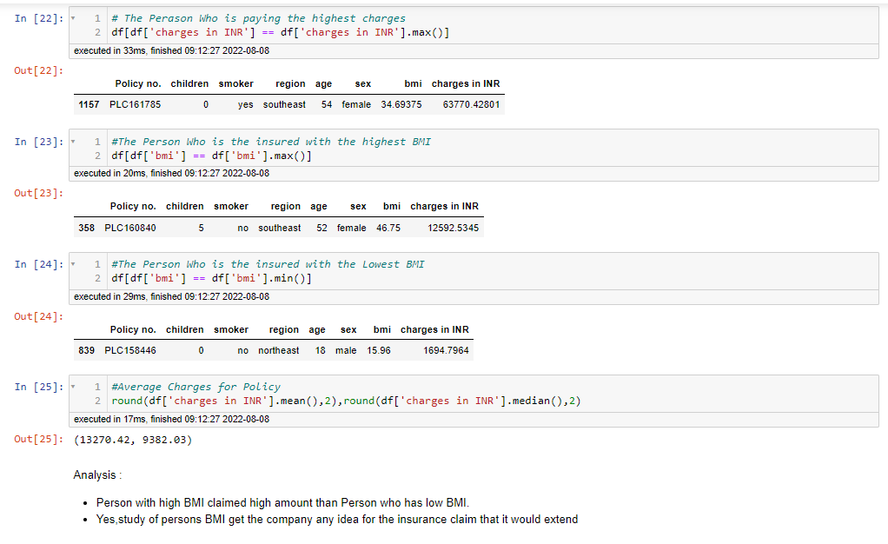

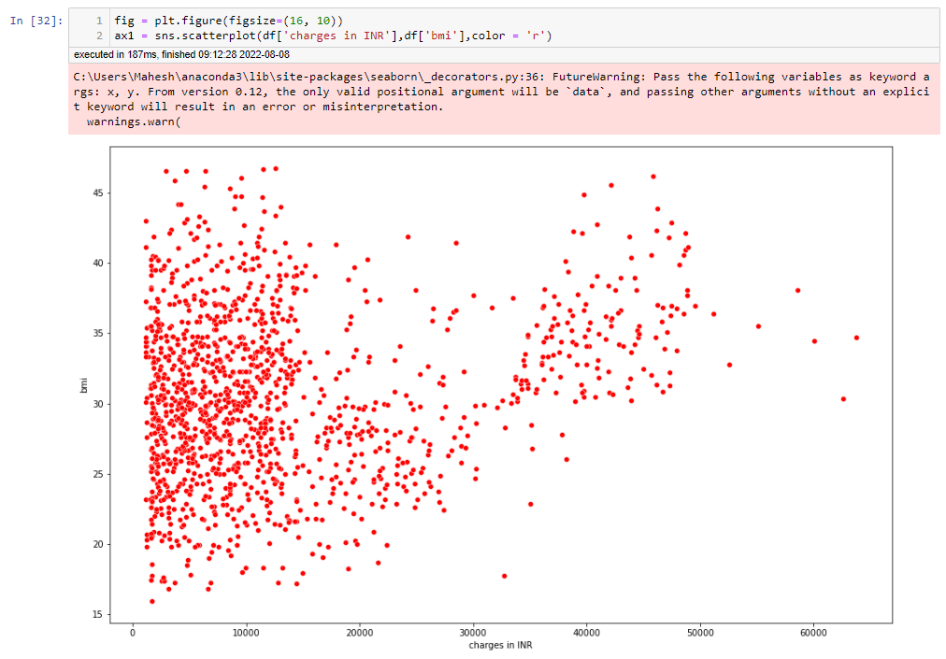

1. **Is it needed for the company to understand whether the person covered is a smoker or a non-smoker?**

**Answer** – Yes, the company to understand whether the person covered is a smoker or a non-smoker

**Justification** –

The amount claimed by smoker is higher than the non-smokers. so, company need to more focus on smokers.

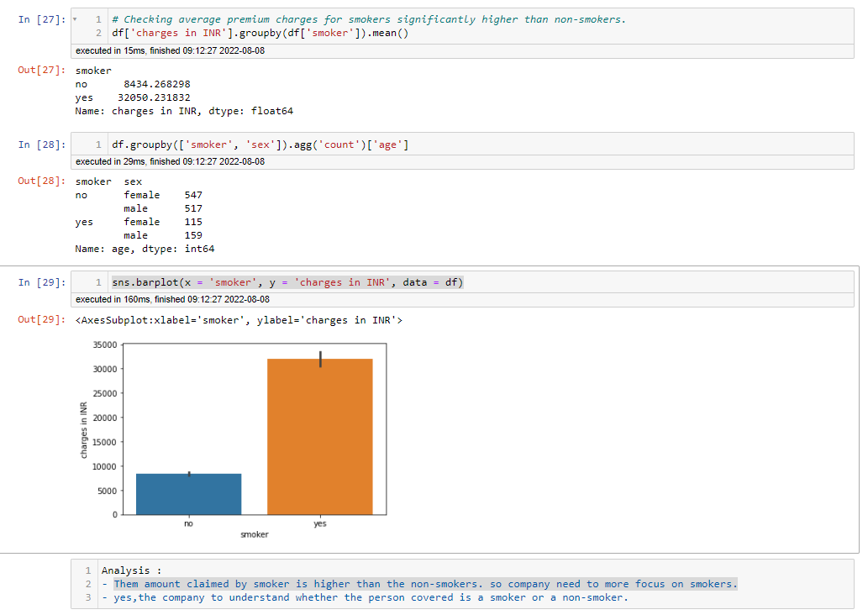

1. **Does age have any barrier on the insurance claimed?**

**Answer** - No age barrier on the insurance claimed.

**Justification** –

Person who has age 18 and 19 claimed a greater number of insurance than other age group people. but all other age groups equally Contributed in insurance claim. So, there is no age barrier on the insurance claimed.

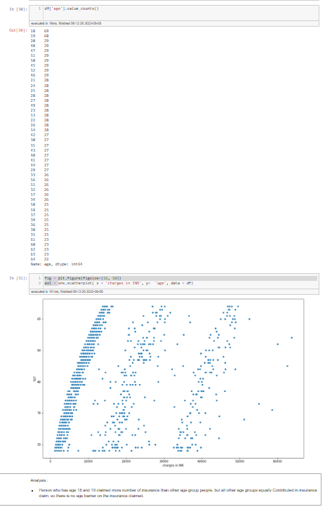

1. **Can the company extend certain discounts after checking the health status (BMI) in this case?**

**Answer** – Yes, company need to extend certain discounts for low BMI persons.

**Justification** –

Out of 1338 persons, 188 person who has low (18 to 24) BMI. Also, the persons who has low BMI are claimed less amount than person who has high BMI.

To attract persons who has low BMI. company need to extend certain discounts for low BMI persons.

